
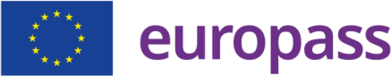
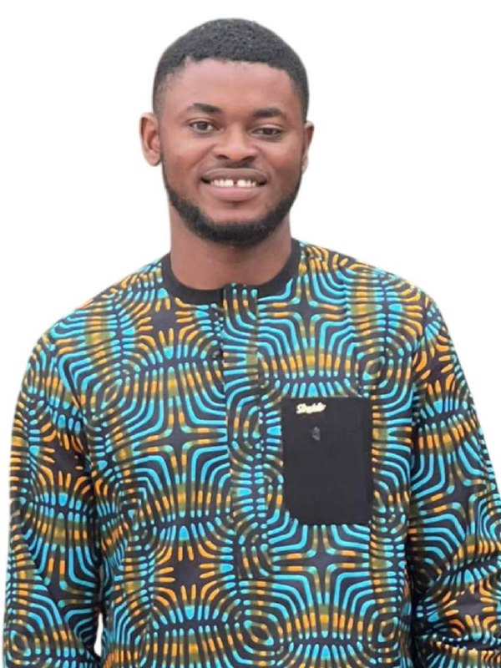


OBAM LOUIS MICHEAL
Nationality: Nigerian (Nigeria) Date of birth: 10/05/1999
Phone number: (+234) 8039142522
Email address: obamlouis5@gmail.com
LinkedIn: louis obam micheal
Website: https://abelonuh.my.canva.site/abel-o

Home: Obam Ladi Compound, Nathanial Akua St., Benue (Nigeria)

ABOUT ME

I am a graduate Geologist with a strong commitment to advancing sustainable groundwater exploration and management. My academic journey culminated in a top-tier performance at Federal University of Technology, Minna, which has been complemented by impactful research on using advanced technology in groundwater exploration. Beyond academics, I have worked as a geologist specializing in carrying out geophysical surveys using advanced methods and technology for groundwater exploration. I aim to leverage the expertise of the France Excellence Eiffel Scholarship through the Master's programme in Earth and Planetary Sciences, Environment (STPE) at the University of Toulouse to develop advanced scientific and technical skills that will enable me to contribute to innovative, reliable, and sustainable groundwater exploration methods, particularly in underserved communities in Nigeria and beyond.

WORK EXPERIENCE

Groundwater Exploration Geologist
AquaMark Integrated Service [ 02/02/2025 – present ]
City: Abuja | Country: Nigeria
- Conducted geophysical surveys for water exploration for over 20 communities using modern PQWT-TC 150 equipment, enhancing project accuracy and efficiency.
- Supervised over 10 drilling projects for boreholes, achieving a 90% success rate in locating viable water sources, which significantly improved access to clean water for the communities.
- Utilized QGIS for producing base and geological maps and for interpreting and analyzing spatial data that significantly enhanced project decision-making and resource assessment.

Exploration Geologist Intern
Nigeria Geological Survey Agency [ 09/2023 – /02/2024 ]
City: Abuja | Country: Nigeria
- Assisted in map interpretation and cartographic activities within the Map and Cartography Unit, developing skills in reading and analyzing base maps and identifying key geographical and geological features.
- Supported fellow interns in understanding base-map features and interpretation techniques, demonstrating teamwork, peer leadership, and effective knowledge sharing.
- Acquired practical experience in map generation and spatial data visualization using ArcGIS for geological and cartographic applications.
- Participated in borehole water-quality assessment, measuring parameters such as pH and salinity using field instruments to support groundwater evaluation.

Undergraduate Research Work

Geophysical Investigation of Groundwater Potential in Part of Maitumbi, Minna.
Federal University Of Technology Minna [ 09/2024 – 12/2025 ]
City: Abuja | Country: Nigeria | Name of unit or department: Geology

- Conducted a comprehensive desk study by reviewing previous journals on former geophysical investigations in the area.
- Utilized ArcGIS software to produce a detailed map of the region.
- Carried out a geophysical survey across five traverses using the modern PQWT -TC 150 equipment, enabling the assessment of the subsurface to identify locations with economic groundwater potential.
- Developed a hydrogeological map of the area based on collected data, indicating areas of potential water accumulation with approximately 95% accuracy, aiding the community in addressing water scarcity issues.

EDUCATION AND TRAINING

BTECH in Geology
Federal University of Technology Minna [ 18/02/2019 – 09/01/2024 ]
City: Minna | Country: Nigeria | Website: www.futminna.edu.ng | Final grade: Magna Cum Laude |
Level in EQF: EQF level 6 |
Thesis: Geophysical Investigation of Groundwater Potential in Part of Maitumbi, Minna

Senior School Certificate
Goodnews Secondary Grammar School [ 05/09/2011 – 25/07/2017 ]
City: Benue | Country: Nigeria | Level in EQF: EQF level 3

LANGUAGE SKILLS

Mother tongue(s): English

DIGITAL SKILLS

Microsoft Office / Microsoft Excel / Microsoft PowerPoint / QGIS AND ArcGIS pro/Remote Sensing/ groundwater and surface water modelling/Programming: Python, MATLAB and SQL, Node.js / Data Science | Machine learning

PROFESSIONAL DEVELOPMENT / CERTIFICATES

[ 2026 ]

Modeling the flow of water on the surface ( Geoversity)
[ 2026]

Coordinate Reference System, Projection and spatial data representation (Geoversity)

[ 2026]

ISO 14001:2015 Environmental Management System Awareness (The Knight Safety)

[ 2026]

Automated GIS workflows with PyQGIS (Mind Lustre)

[ 2026]

Exploration of Copernicus and Sentinel Data (Geoversity)

[ 2026]

Earth Observation for Ecosystem Conservation II (Geoversity)

[ 2026]

Introduction to Agent-Based Modeling (Geoversity)

[ 2026]

Automated GIS workflows with PyQGIS (Mind Lustre)
[ 2026]

Become a Professional Python Programmer (Udemy)
[ 2026]

Fundamentals of Remote Sensing(NASA)
[ 2026 ]

Machine Learning ( Fly Rank AI)

VOLUNTEERING

Volunteer — Water for Life Project [ 07/2023 ]
City: Minna–Bosso area, | Country: Nigeria
- Participated in a community water-access initiative focused on groundwater exploration and borehole development in the Minna–Bosso area.
- Assisted with field activities such as geophysical surveys, analysis of geological features, and satellite images related to groundwater exploration and monitoring during borehole drilling.

